

**Assignment on**

Electronic Device and Circuits

Topic: p-type Semiconductor

Course Code: CSE224

Submitted by :

ID :

Section : A

Submission Date:

Submitted to : MD. SAYEDUL AREFIN

Designation : Lecturer

Department : Department of Computer Science and

Engineering

## ***P-Type Semiconductor:***

When the trivalent impurity is added to an intrinsic or pure semiconductor (silicon or germanium), then it is said to be an p-type semiconductor. Trivalent impurities such as Boron (B), Gallium (G), Indium(In), Aluminum(Al) etc. are called acceptor impurity.

Let us consider, trivalent impurity boron is added to silicon as shown in below figure. Boron atom has three valence electrons and silicon has four valence electrons. The three valence electrons of each boron atom form 3 covalent bonds with the 3 neighboring silicon atoms.

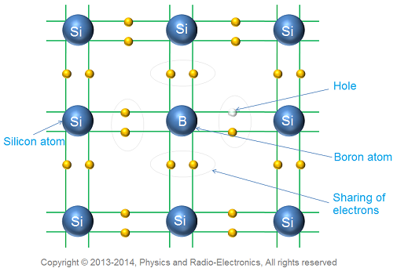

In the fourth covalent bond, only silicon atom contributes one valence electron, while the boron atom has no valence electron to contribute. Thus, the fourth covalent bond is incomplete with shortage of one electron. This missing electron is called hole.

This shows each boron atom accept one electron to fill the hole. Therefore, all the trivalent impurities are called acceptors. A small addition of impurity (boron) provides millions of holes.

## ***Charge on p-type semiconductor:***

So many people think that p-type semiconductor has large number of holes and current conduction is mainly due to these holes. So, the total electric charge of p-type semiconductor is positive. But this assumption is wrong. Even though p-type semiconductor has large number of holes, but these holes is provided by the trivalent atoms that are electrically neutral. Therefore, the total electric charge of p-type semiconductor is also neutral.

## ***Conduction in p-type semiconductor:***

Let us consider a p-type semiconductor as shown in below figure. When voltage is applied to p-type semiconductor; the holes in valence band moves towards negative terminal of applied voltage. Similarly, free electrons move towards positive terminal of applied voltage.

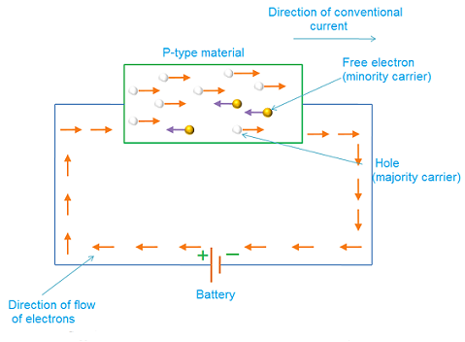

In p-type semiconductor, the population of holes in valence band is more, whereas the population of free electrons in conduction band is less. So, current conduction is mainly because of holes in valence band. Free electrons in conduction band constitute little current. Hence in p-type semiconductor, holes are called majority carriers and free electrons are called minority carriers.